**Data Communication And Networking**

**Date: 19.02.21**

**Name: RAJUL DUBEY**

**SAP ID: 500069424**

**ROLLNo.: R171218081**

**Task: 1 with the help of server.**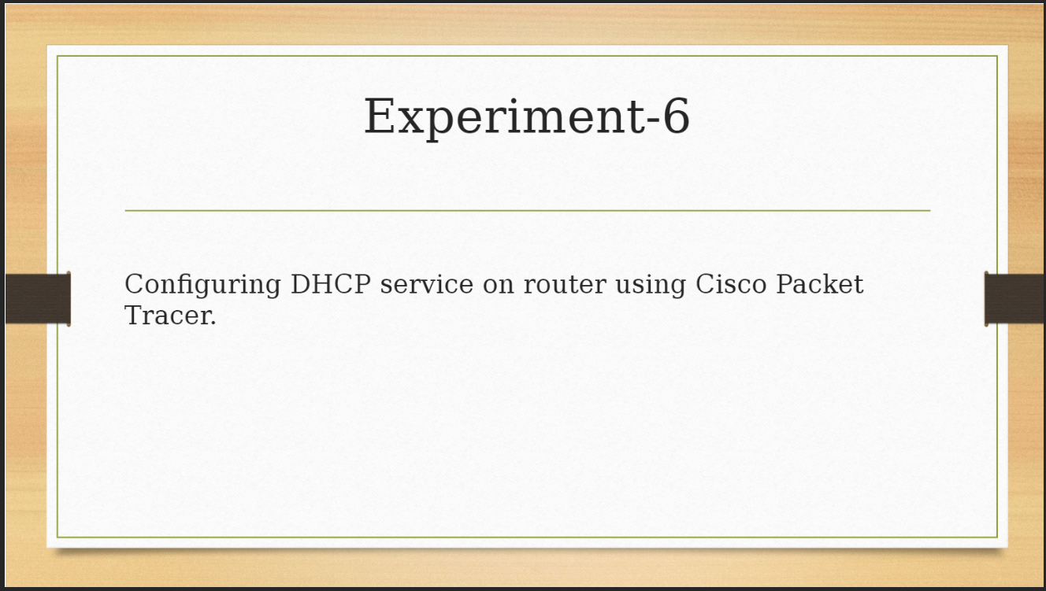

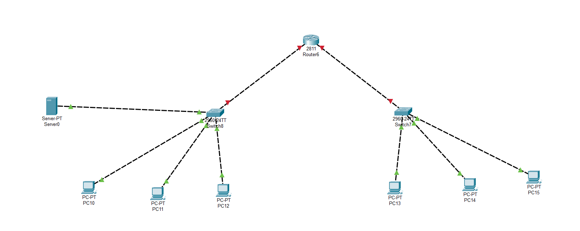

**Device Requirements:**

**Router 1,Server 1,swtiches 2, pcs n**

**Step 1:** Connect both the switches to the router

**Step 2:** Connect a Server to switch 1

**Step 3:** Connect pcs to switches 1 and 2

**Step 4:** Now configure the Router to stablish a connection b/w Switch 1 and Switch 2

Through Router’s CLI

**Commands:**

en

conf t

int f0/0 //for Ethernet cable 0 connected switch

ip add 192.168.1.1 255.255.255.0 (for exp)

no shut

exit

int f0/1 //For Ethernet cable 1 connected switch

ip add 192.168.2.1 255.255.255.0

no shut

exit

**Step 5:** Now configure the Server

Click on the Server

i.)

config->Global->setting

default gateway: 192.168.1.1

ii.)

config->FastEthernet0

Ip Configuration:

Static

Ipv4: 192.168.1.2

255.255.255.0

iii.)

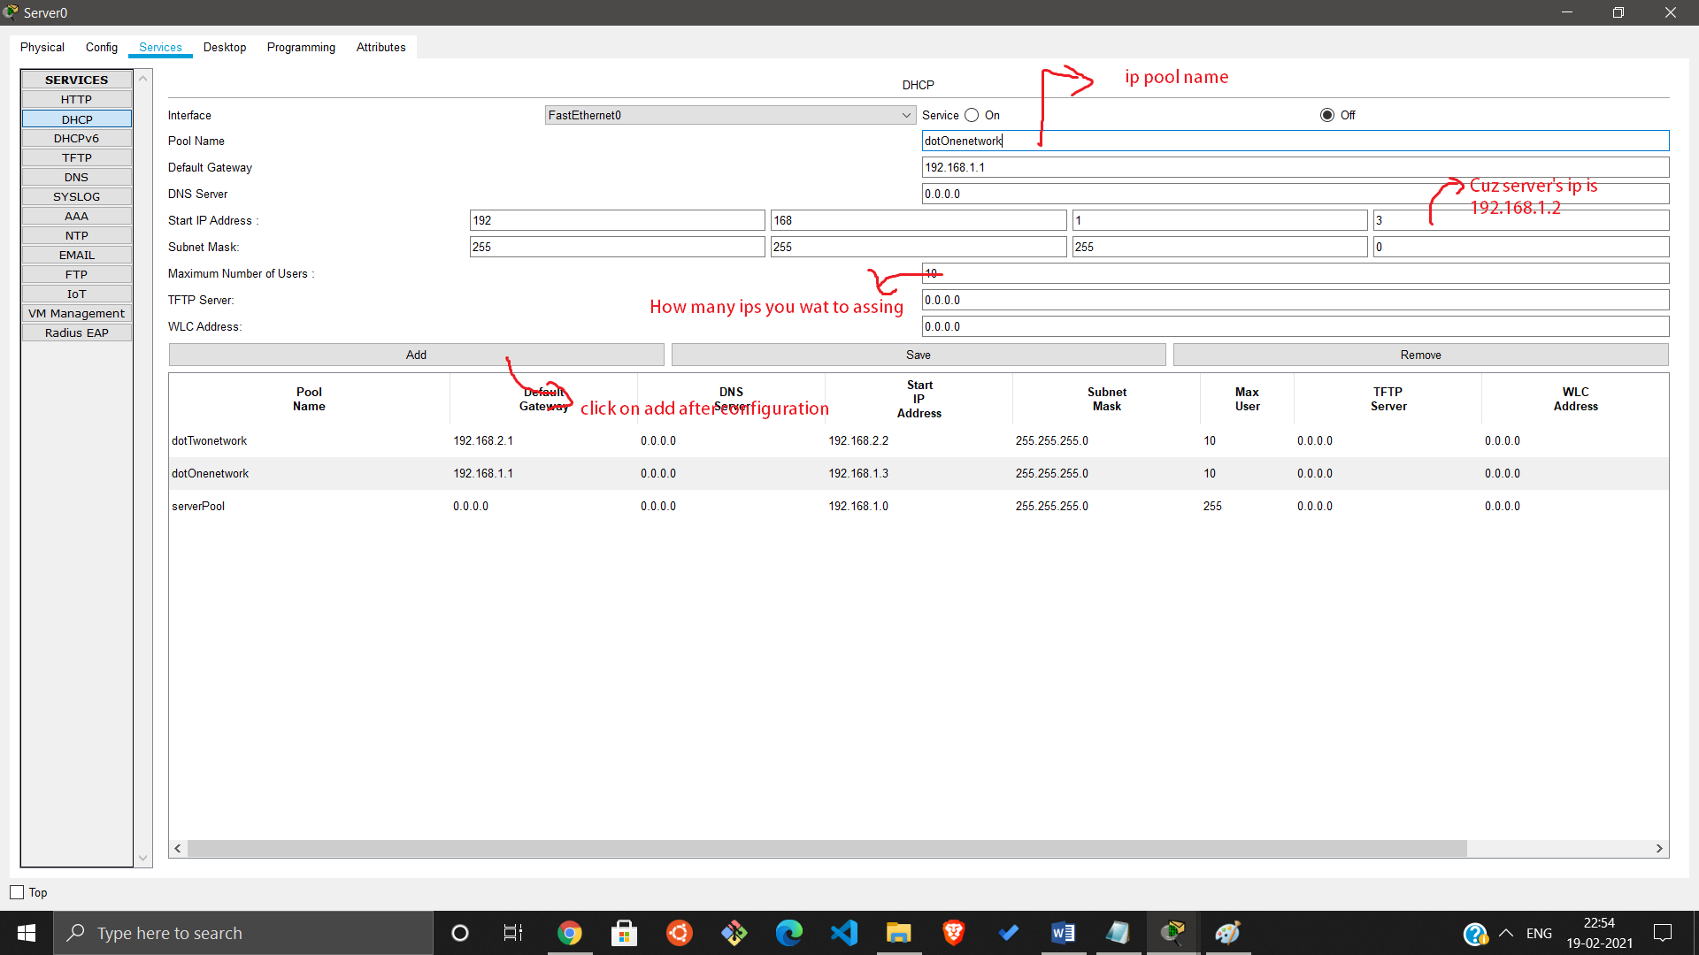Services->DHCP->

**Step 6:** Now Configure the router to distribute ips in both switches

*Router’s CLI

**Commans:**

**en**

**conf t**

**int f0/0**

**ip helper-address 192.168.1.2 (Server’s ip)**

**no shut**

**exit**

**int f0/1 (For another router)**

**ip helpter-address 192.168.1.2**

**no shut**

**exit**

**Step 7:**

Now go to any pc of any network and go to **IP Configuration**

And click on **DHCP**

Now your pc will get a ip Dynamically

**Task: 2 Use Router as a Server.**

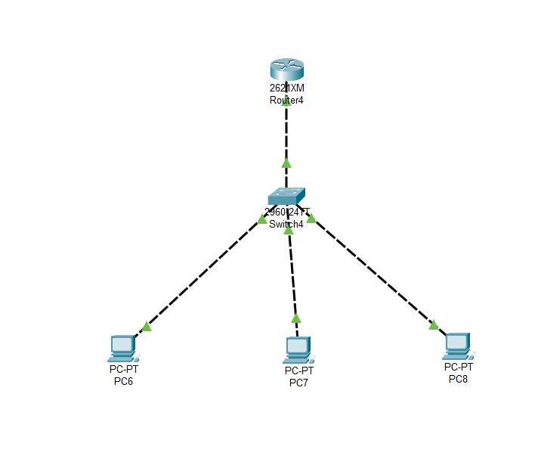

**Step 1:** Make the arrangement like picture

above

**Step 2:** Configure the router through CLI

**Commands:**

**en**

**conf t**

**int** f0/0  **(Through which it’s connected)**

**ip add** 192.168.1.1 255.255.255.0

**no shut**

**exit**

**ip dhcp pool** dotOne (pool name)

**default-router** 192.168.1.1 (DG)

**network** 192.168.1.0 255.255.255.0

**exit**

**int** f0/1  **(Through which it’s connected)**

**ip add** 192.168.2.1 255.255.255.0

**no shut**

**exit**

**ip dhcp pool** dotTwo(pool name)

**default-router** 192.168.2.1 (DG)

**network** 192.168.2.0 255.255.255.0

**exit**

**do wr**

**Step 3:** Now go to any pc of any network and go to **IP Configuration**

And click on **DHCP**

Now your pc will get a ip Dynamically